**ASTHMATIC SEVERITY ANALYSIS FROM CAPNOGRAM SIGNAL**

**A PROJECT REPORT**

***Submitted by***

**S.AISHWARYA**

**C.BHARATHI VIDHYA**

**K.M.MENITA**

**K.PREETHI**

***in partial fulfillment for the award of the degree***

***of***

**BACHELOR OF ENGINEERING**

**in**

INSTRUMENTATION AND CONTROL ENGINEERING

**SRI SAIRAM ENGINEERING COLLEGE**



**ANNA UNIVERSITY: CHENNAI 600 025**

APRIL 2016

**ANNA UNIVERSITY: CHENNAI 600 025**

**BONAFIDE CERTIFICATE**

Certified that this project report **“ASTHMATIC SEVERITY ANALYSIS FROM CAPNOGRAM SIGNAL”** is the bonafide work of “ **S.AISHWARYA (412512112004) , C.BHARATHI VIDHYA (412512112010) , K.M.MENITA (412512112028) , K.PREETHI (412512112035) ”** who carried out the project work under my supervision.

**SIGNATURE SIGNATURE**

Ms. T. Mangayarkarasi

**HEAD OF THE DEPARTMENT SUPERVISOR**

Department of Instrumentation and Department of Instrumentation and

Control Engineering Control Engineering

Sri Sairam Engineering College Sri Sairam Engineering College

Chennai – 600 044 Chennai – 600 044

Submitted for the Anna University Examination held on -------------------------

**(INTERNAL EXAMINER) (EXTERNAL EXAMINER)**

**ACKNOWLEDGEMENT**

We thank our founder chairman **Thiru. MJF.Ln.LEO MUTHU** for his great endeavours in establishing this institution and stand as a figure of guidance.

We also thank our **CEO Mr. SAI PRAKASH LEO MUTHU** and our Principal **Dr. C.V.Jayakumar** for their kind cooperation and inspiration.

We thank **Ms. T.MANGAYARKARASI**, Professor and Head of the department, Instrumentation and Control Engineering for giving us the freedom to carry out the project work in chosen domain. With profound sense and regards, we express our deepest sense of respect for her excellent guidance, constant encouragement and support.

We thank our project coordinator **Ms. B. GOWRISHWARI,**  Assistant Professor, for her constant support from the commencement of the project work and also for providing us with necessary details with regard to the presentation and documentation.

Our gratitude extends to the staff of ICE department, for their motivation and valuable ideas provided during periodic reviews. We would like to thank our parents and friends for their valuable support and encouragement.

Finally, we thank the Almighty for his blessings to accomplish our task successfully.

**TABLE OF CONTENTS**

|  |  |  |
| --- | --- | --- |
| **CHAPTER NUMBER** | **TITLE** | **PAGE NUMBER** |
|  | ABSTRACT |  |
| **1** | **INTRODUCTION** |  |
| **1.1** | ASTHMA – DEFINITION AND CAUSES |  |
| **1.2** | CONCEPT PRESENTED |  |
| **1.3** | EXISTING METHOD |  |
| **1.4** | RESPIRATORY SYSTEM |  |
| **1.5** | CAPNOGRAPHY TECHNIQUE |  |
| **1.6** | CAPNOGRAM |  |
| **2** | **LITERATURE SURVEY** |  |
| **2.1** | WIRELESS SENSOR NETWORKS IN MONITORING OF ASTHMA |  |
| **2.2** | CAPNOGRAM FEATURE EXTRACTION BASED ON WAVELET DECOMPOSITION |  |
| **2.3** | FREQUENCY ANALYSIS OF CAPNOGRAM SIGNALS TO DIFFERENTIATE ASTHMATIC AND NON-ASTHMATIC CONDITIONS |  |
| **3** | **SYSTEM DESIGN** |  |
| **3.1** | BLOCK DIAGRAM |  |
| **3.2** | BLOCK DIAGRAM DESCRIPTION |  |
| **3.3** | PROBABILISTIC NEURAL NETWORKS (PNN) |  |
| **4** | **SOFTWARE DESCRIPTION** |  |
| **4.1** | MATLAB |  |
| **4.2** | ALGORITHM |  |
| **4.3** | PROCESS EXPLANATION |  |
| **5** | **RESULTS AND DISCUSSION** |  |
| **5.1** | RESULTS OBTAINED |  |
| **5.2** | GRAPHICAL USER INTERFACE |  |
| **5.3** | ADVANTAGES OF THE PROPOSED SYSTEM |  |
| **5.4** | FUTURE WORK |  |
|  | REFERENCES |  |

**ASTHMATIC SEVERITY ANALYSIS FROM CAPNOGRAM SIGNAL**

**ABSTRACT:**

Asthma is one of the chronic lung diseases that inflames and narrows the airways. This project aims at analyzing the se­­­verity of asthma and classifying asthma into different stages. It involves developing a computer aided patient assistive tool for the dynamic analysis of the severity. Capnogram signals obtained from patient databases and knowledge regarding severity levels from an asthma specialist was utilized as inputs for the project. Capnogram is a graph which displays a plot of exhaled carbon di-oxide level (kPa) over time. These capnogram signals are preprocessed by Median Filter and Windowing technique to eliminate unnecessary noise and for obtaining the respective amplitude-time peaks. The statistical features are thus extracted. The features extracted from the signal are the amount of End-Tidal Carbon di-oxide (ETCO2), minimum point and the average stem of the capnogram signal. The ETCO2 is compared with its standard range and the asthma severity is classified into normal ventilation, hyperventilation (mild) and hypoventilation (severe). Further, hypoventilation is classified into three stages. This classification is done using the Probabilistic Neural Network (PNN) Algorithm. The signal processing and classification Algorithms are implemented as M-file Program in MATLAB version 2009a. A graphical user friendly interface is developed to assist the physician to process the capnogram of the affected patient effectively.

**CHAPTER 1**

**INTRODUCTION**

**1.1 ASTHMA – DEFINITION AND CAUSES**

Asthma is a disease affecting the airways that carry air to and from the lungs. The inside walls of an asthmatic's airways are swollen or inflamed. This swelling or inflammation makes the airways extremely sensitive to irritations and increases the susceptibility to an allergic reaction. As inflammation causes the airways to become narrower, less air passes through them, both to and from the lungs. Symptoms of the narrowing include wheezing (a hissing sound while breathing), chest tightness, breathing problems, and coughing. Asthmatics usually experience these symptoms most frequently during the night and the early morning.

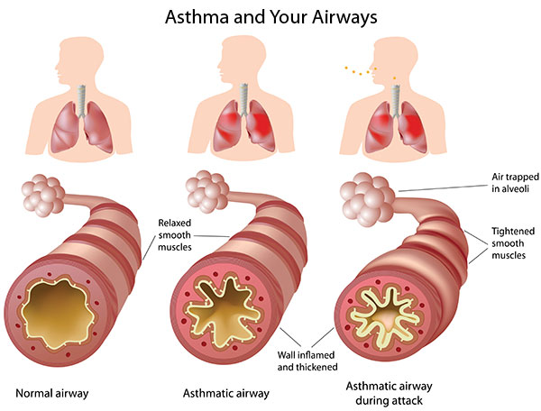

**1.2 CONCEPT PRESENTED**

This project proposes the idea of collecting the database of asthmatic patients and analyzing them to determine the severity of asthma. For this, capnogram signals are collected and pre-processed. Capnogram is a graph which displays a plot of exhaled carbon di-oxide level (kPa) over time. This is obtained as a result of a technique called Capnography. Median filter along with masking window is used for pre-processing. From these pre-processed signals, various statistical features are extracted and compared with the standard range of values obtained from a healthy person. Based on this comparison, the severity of asthma is classified into hyperventilation, normal ventilation, bronchospasm and hypoventilation. Further hypoventilation is classified into three stages. This classification is done using Probabilistic Neural Network (PNN) which is implemented in MATLAB.

**1.3 EXISTING METHOD**

Traditionally, spirometers and peak flow meters are used to detect any signs of asthma.

**PEAK FLOW METER:**

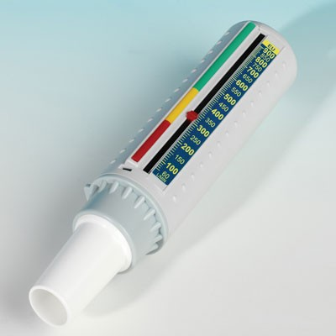

Peak flow meter will monitor the strength of lung exhalation by measuring peak expiratory flow rate (PEFR) which is used to determine the severity of bronchospasm and the degree of airway obstruction of the patient. By using all this information, the doctors are able to monitor and determine the asthmatic condition. But the patients are required to take a deep breath as deep as they can and then blow hard as fast as possible and repeat the process about two to three times. This method brings some negative feedback to patients as they feel dizzy after use the device.

**SPIROMETER:**

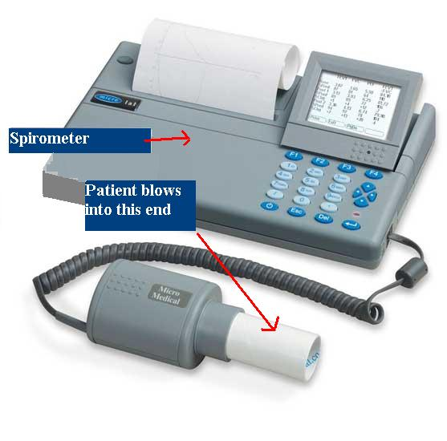

Spirometer is another apparatus for diagnosing asthma. It measuring the volume of inspired and expired air by the lungs. It is used to measure the amount of air a person can hold in the lungs and the time taken for the lungs to be emptied and filled. Spirometer is a very patient dependent tool and the patients must give full cooperation so that the device will be able to detect the clinically important reduction. The main disadvantage of this method is that it is very sensitive to temperature, humidity and atmospheric pressure of surrounding air. Thus, they must be calibrated very often.

**CLINICAL ASSESSMENT:**

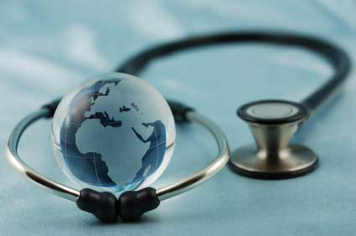

Another method used to diagnose asthma in patients is clinical assessment. The first step done by the doctors is inquiring the patient’s background and focusing more on the medical history. This is to identify the symptoms, the occurrence and any possible asthma trigger such as allergens. A physical test is conducted especially around the upper respiratory tract for observing the wheezing sound and nasal secretion or any similar allergy-related symptoms. A symptoms record is maintained and the data obtained is often used in clinical trials. The drawback in clinical assessment is that the symptoms obtained from the patient’s medical history may not indicate the severity of the disease and there is no strong evidence regarding the patient’s health.

**1.4 RESPIRATORY SYSTEM**

The primary function of the respiratory system is to exchange oxygen and carbon dioxide. Inhaled oxygen enters the lungs and reaches the alveoli. The layers of cells lining the alveoli and the surrounding capillaries are each only one cell thick and are in very close contact with each other. This barrier between air and blood averages about 1 micron in thickness. Oxygen passes quickly through this air-blood barrier into the blood in the capillaries. Similarly, carbon dioxide passes from the blood into the alveoli and is then exhaled.

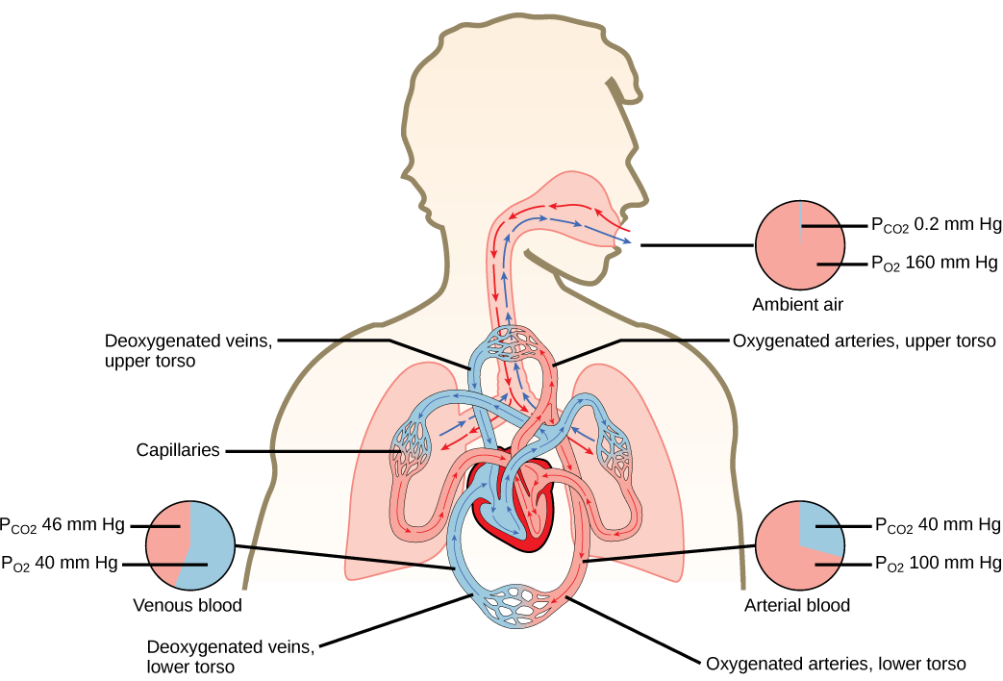

Oxygenated blood travels from the lungs through the pulmonary veins and into the left side of the heart, which pumps the blood to the rest of the body. Oxygen-deficient, carbon dioxide-rich blood returns to the right side of the heart through two large veins, the superior vena cava and the inferior vena cava. Then the blood is pumped through the pulmonary artery to the lungs, where it picks up oxygen and releases carbon dioxide.

To support the exchange of oxygen and carbon dioxide, about 5 to 8 liters (about 1.3 to 2.1 gallons) of air per minute are brought in and out of the lungs, and about three tenths of a liter of oxygen is transferred from the alveoli to the blood each minute, even when the person is at rest. At the same time, a similar volume of carbon dioxide moves from the blood to the alveoli and is exhaled. During exercise, it is possible to breathe in and out more than 100 liters (about 26 gallons) of air per minute and extract 3 liters (a little less than 1 gallon) of oxygen from this air per minute. The rate at which oxygen is used by the body is one measure of the rate of energy expended by the body. Breathing in and out is accomplished by respiratory muscles.

Three processes are essential for the transfer of oxygen from the outside air to the blood flowing through the lungs: ventilation, diffusion, and perfusion. Ventilation is the process by which air moves in and out of the lungs. Diffusion is the spontaneous movement of gases, without the use of any energy or effort by the body, between the gas in the alveoli and the blood in the capillaries in the lungs. Perfusion is the process by which the cardiovascular system pumps blood throughout the lungs.

**1.5 CAPNOGRAPHY TECHNIQUE**

Capnography is a non-invasive tool used to measure the concentration or partial pressure of carbon dioxide (CO2) level during respiration. It provides information about CO2 production, pulmonary (lung) perfusion, alveolar ventilation, respiratory patterns, and elimination of CO2 from the anesthesia breathing circuit and ventilator. The reason for using capnography technique is as follows:

* Capnography provides information about CO2 production, pulmonary perfusion, alveolar ventilation, respiratory patterns, and elimination of CO2 from the anesthesia circuit and ventilator.
* Capnography is effective in the early detection of adverse respiratory events.
* Capnography also facilitates better detection of potentially life-threatening problems than clinical judgment alone.

Capnography is done mainly using two methods namely, physical method and chemical method. (Figure1)

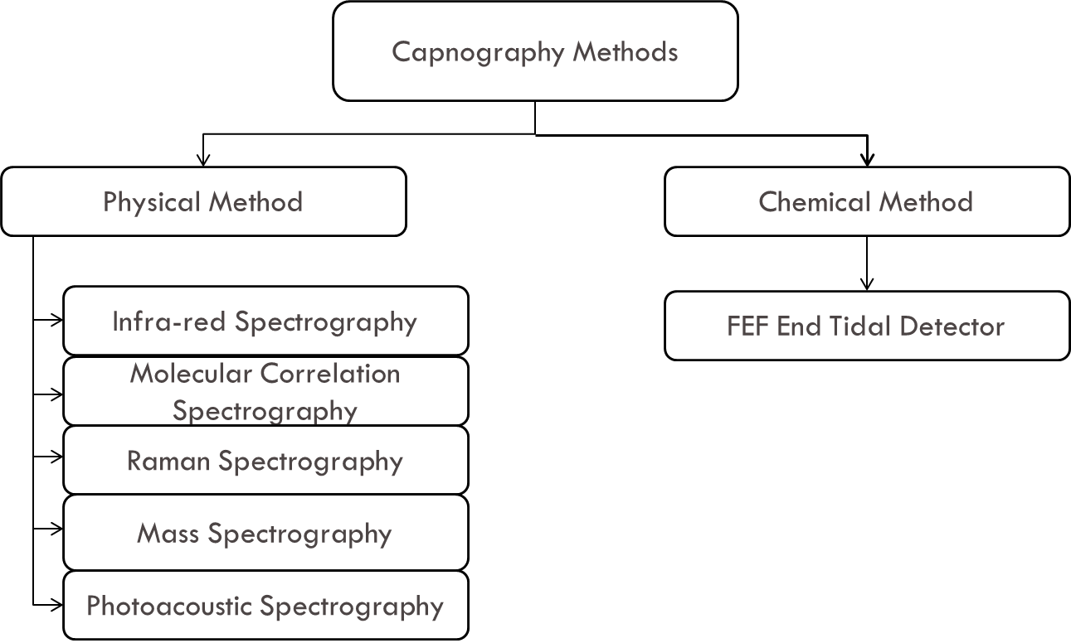

Figure 1: Capnography Methods

**PHYSICAL METHOD:**

1. **Infra-Red Spectrograph:** Infra-red spectrographs are more compact and less expensive than the other methods of measurement. This has been the most popular technique for monitoring C02. The wavelength of IR rays exceeds 1.0 milli micron while the visible spectrum is between 0.4 and 0.8 milli microns. The IR rays are absorbed by polyatomic gases (non-elementary gases such as nitrous oxide (N20), C02, and water vapour. Carbon dioxide selectively absorbs specific wavelengths (4.3 milli microns) of IR light. Since the amount of light absorbed is proportional to the concentration of the absorbing molecules, the concentration of a gas can be determined by comparing the measured absorbance with the absorbance of a known standard. The C02 concentration measured by the monitor is usually expressed as partial pressure in mmHg, although some units display percentage C02 (FC02), obtained by dividing C02 partial pressure by the atmospheric pressure.
2. **Molecular Correlation Spectrography (MCS):** Micro stream technology is built on unique approach to IR radiation emission. Laser-based technology, i.e., molecular correlation spectroscopy (MCS), is used to generate an IR emission that precisely matches the absorption spectrum of CO2 molecule.  The high emission efficiency and extreme CO2 specificity and sensitivity of the emitter-detector combination allows for an extremely short light path which allows the use of very small sample cell (15 µl). This in turn permits the use of a very low flow rate (50 ml/min) without compromising accuracy or responsive time. This is in contrast to conventional CO2 IR method, where the sampling flow rate is 150 ml/min.

Micro stream technology uses a novel MCS source that operates at room temperature and emits only CO2 specific radiation. The source emits approximately one hundred discrete lines spread out in the 4.2 to 4.35 µm regions with a Boltzman distribution.  The individual lines each have widths of 0.004 cm-1 while being separated from each other with the characteristic CO2 spacing of 1 to 1.5 cm-1. The MCS source is therefore emitting extremely thin lines of radiation in the very narrow but discrete CO2 wavelengths without any superfluous radiation outside of these wavelengths. This results in a greater than 1 to 200 ration between line widths and the distance between the lines, which leaves large amounts of empty space free of radiation.  This allows Micro stream technology to eliminate any over-lap or interference with other gases.

The mechanism of MCS is as follows: The source, unlike the black body IR radiator, is an all glass discharge lamp, without an electrode, coupled with an IR transmitting window which is either sapphire (for very high outputs and low noise) or high transmitting IR glass (for standard functions). The glass lamp undergoes a special cleaning process as well as chemical conditioning before being filled with a carefully balanced mixture of up to 7 gases at low pressure. Electrons generated by a radio frequency voltage excite Nitrogen molecules, one of the gases within the source.

Carbon dioxide molecules are then excited through collision with the excited nitrogen molecules as energy is transferred from Nitrogen to the CO2 molecules. As the excited CO2 molecules drop back to their ground state they emit signature wavelength of CO2, which is the radiation emitted from the source.

1. **Molecular correlation spectroscopy signal processing:** The IR source is electronically modulated at a frequency of 20 Hz so that a measurement can be sampled every 25 msecs. This preserves a rapid response time while maintaining optimal signal characteristics without degradation. The amplitude of each signal received by the detector is dependent on the amount of radiation absorbed from the gas sample that is proportional to the CO2concentration. The signals from the optical detector are amplified and frequency locked before being delivered for peak to peak sampling with 12 BIT A to D converter. This provides a 25 msec periodic voltage signal, reflecting the level of CO2 absorption. These voltages are then transformed to CO2 concentrations using the anticipated absorption curves for the instantaneous ambient conditions.  Because of the highly specific nature of the MCS source, the exponential shaped absorption curves are very deep.

In a gas sample with a concentration of 5% CO2, absorption greater than 50% of the source emitted radiation occurs using the standard 15 µl cell.

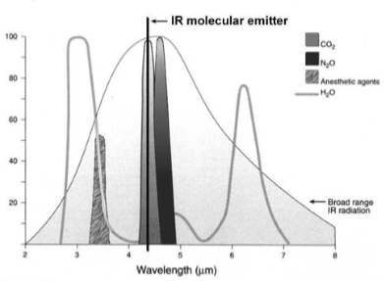

At concentration of 10% CO2, absorption of more than 65% can be expected. As a result of the high sensitivity and specificity of MCS absorption characteristic exponential shape of the MCS absorption curve, the low concentration regions demonstrate large changes of absorption and therefore changes in signal.  This phenomena is present even for small variances in CO2 concentration and provides high signal to noise characteristics in the final displayed waveform.   
To further enhance the waveform signal to noise, without affecting the response time, dynamic averaging of the 25 msec signal is used. The degree of dynamic averaging is proportional to the rate of change of the signal. In this method, only with slow changing signals, indicative of the alveolar CO2 plateau or the inhalation phase, is averaging applied. When fast changing signals are detected, indicative of the ascending CO2 upstroke, all signals averaging is removed.

Micro stream employs a flow rate of 50 ml/min, one-half to one-third the rate typically required by conventional side-stream capnographs. It has been suggested that the low flow rate reduces the entry of moisture and humidity that can condense in the sampling line and obstruct the sample pathway - a common problem with conventional side-stream technology.3 The low flow rate also maintains accuracy while eliminating the competition for tidal volume, common with high flow rate capnographs in infants and neonates. A flow rate as low as 50 ml/min was not generally provided with previous capnographs since it had a detrimental effect on response time and the ability to address rapid respiratory rates and the ability to measure CO2 accurately without mixing.

1. **Raman Spectrography:** Raman Spectrography uses the principle of "Raman Scattering" for CO2 measurement. The gas sample is aspirated into an analyzing chamber, where the sample is illuminated by a high intensity monochromatic argon laser beam. The light is absorbed by molecules which are then excited to unstable vibrational or rotational energy states (Raman scattering). The Raman scattering signals (Raman light) are of low intensity and are measured at right angles to the laser beam. The spectrum of Raman scattering lines can be used to identify all types of molecules in the gas phase. Raman scattering technology has been incorporated into many newer anesthetic monitors (RASCAL monitors) to identify and quantify instantly CO2 and inhalational agents used in clinical practice.
2. **Mass Spectrography:** The mass spectrograph separates molecules on the basis of mass to charge ratios. A gas sample is aspirated into a high vacuum chamber (10-5 mmHg) where an electron beam ionizes and fragments the components of the sample. The ions are accelerated by an electric field into a final chamber, which has a magnetic field, perpendicular to the path of the ionized gas stream. In the magnetic field the particles follow a path wherein the radius of curvature is proportional to the charge mass ratio. A detector plate allows for determination of the components of the gas and for the concentration of each component. Mass spectrometers are quite expensive and too bulky to use at the bedside and are rarely used presently. They are either "stand alone," to monitor a single patient continuously, or "shared," to monitor gas samples sequentially from several patients in different locations (multiplexed). Up to 31 patients may be connected to a multiplexed system and the gas is simultaneously sampled from all locations by a large vacuum pump. A rotary valve (multiplexer) is used to direct the gas samples sequentially to the mass spectrometer. In a typical 16-station system, with an average breathing rate of 10 breaths min-l, each patient will be monitored about every 3.2 min. The user can interrupt the normal sequence of the multiplexer and call the mass spectrometer to his patient for a brief period of time.
3. **Photoacoustic Spectrography:** Photoacoustic gas measurement (e.g., Bruel-Kjaer gas monitor) is based on the same principles as conventional IR-based gas analyzers: the ability of CO2 and N20 and anaesthetic agents to absorb IR light. However, they differ in measurement techniques. While Infra-red spectrography uses optical methods, PAS uses an acoustic technique.  When an IR energy is applied to a gas, the gas will expand and lead to an increase in pressure. If the applied energy is delivered in pulses the gas expansion would be also pulsatile, resulting in pressure fluctuations. If the pulsation frequency lies within the audible range, an acoustic signal is produced and is detected by a microphone. Potential advantages of PAS over IR spectrometry are higher accuracy, better reliability, less need of preventive maintenance, and less frequent need for calibration. Further, as PAS directly measures the amount of IR light absorbed, no reference cell is needed and zero drift is nonexistent in PAS. The zero is reached when there is no gas present in the chamber. If no gas is present there can be no acoustic signal. Despite being a superior method of measurement of CO2, photo acoustic spectrography did not gain as much popularity as IR spectrography.

**CHEMICAL METHOD:**

**FEF end-tidal detector:** A pH-sensitive chemical indicator is enclosed in a plastic housing and is connected to the gas stream between the endotracheal tube and the anesthesia circuit. The pH sensitive indicator changes color when exposed to C02.The color varies between expiration and inspiration, as C02 level increases or decreases. The color changes from purple (when exposed to room air or oxygen) to yellow (when exposed to 4% C02). The response time of the device is sufficiently fast to detect changes of C02 breath-by breath. However, this device is not very sensitive when CO2 output is low as is during CPR. Easy cap II is an example of such pH sensitive indicator devices.

False negative results may occur even with correct endotracheal tube placement in patients in cardiac arrest, in whom sufficient CO2may not be present in the lungs. It is also more relevant to point out the possibility of color change in the device due to agents other than exhaled carbon dioxide (false positive results). Gastric contents, mucus, and drugs such as epinephrine can cause false positive results. It is imperative that clinicians using these devices be aware of this limitation. One way to avoid this pitfall is to observe the change in color in the device with each breath. A false positive result causes a permanent color change in the device. Hence, the color does not vary with ventilation.

**1.6 CAPNOGRAM**

Using any of the above methods, the capnogram of every patient is recorded. Capnogram is a graph which displays a plot of exhaled carbon di-oxide level (kPa) over time. The shape of the curve is affected by some forms of lung disease; in general there are obstructive conditions such as bronchitis, emphysema and asthma, in which the mixing of gases within the lung is affected. The output of the tool is presented as a graph of expiratory CO2 plotted against time or exhaled volume. A normal capnogram is represented in Figure 2.

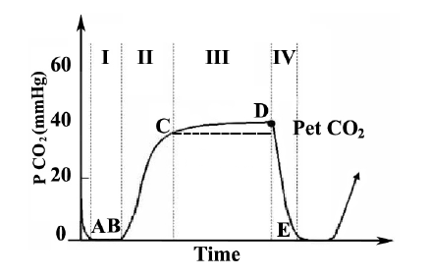

Figure 2: Capnogram of a healthy Patient

A normal capnogram shapes slightly like square wave pattern as shown in Figure 2. It consists of three successive phases:

(1) A latency phase (Phase I), which corresponds to the expiration of the anatomical dead space (PexpCO2= 0), which is indistinguishable from the preceding inspiration.

(2) Slope phase (Phase II) marked by a very rapid rise in (PexpCO2), corresponding to the expiration of mixed air.

(3) Plateau phase (Phase III), reflecting the elimination of alveolar air (slightly increasing PexpCO2), resulting in the peak at the end of tidal expiration (PetCO2 close to alveolar carbon dioxide tensions) The highest peak in the capnogram is known as the end-tidal point.

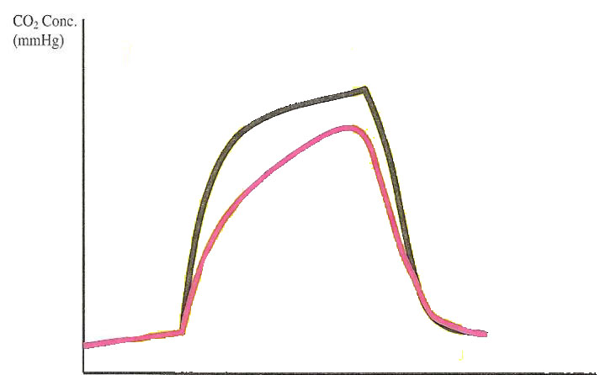

Time (seconds)

Figure 3: Capnogram of an Asthmatic Patient

For an asthmatic patient, the airways are swollen, narrow and have more mucus plugging which cause regional decrease in airflow and alveolar ventilation. Phases II losses its verticality, alpha angle (which also known as angle Q) between Phase II and Phase III is widely opened and Phase III has increased inclination. In severe asthmatic state, the capnogram comes out like a “shark fin” as shown in Figure 3.

**FEATURES OF CAPNOGRAM:**



* + **ETCO2:**
* Normal : 35 – 45 mmHg (4.0-5.7 kPa)
* Hypoventilation : > 45 mmHg (>5.7 kPa)
* Hyperventilation : < 35 mmHg (<4.0 kPa)
  + **ALPHA ANGLE** : 100 degrees to 110 degrees
  + **BETA ANGLE** :around 90 degrees

**ASTHMA CLASSIFICATION:**

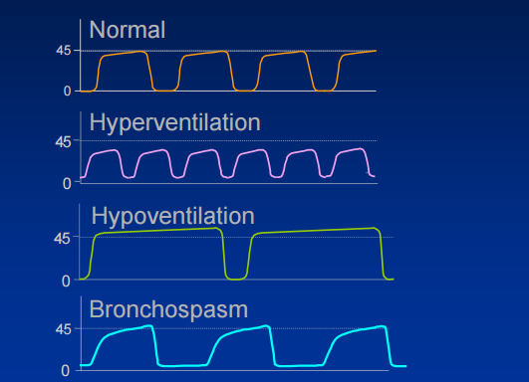

**CHAPTER 2**

**LITERATURE SURVEY**

**2.1 WIRELESS SENSOR NETWORKS IN MONITORING OF ASTHMA**

Dinko Oletic

Faculty of Electrical Engineering and Computing

Universitiy of Zagreb

**ABSTRACT:**

The problem of persistent asthma management is introduced with a short overview of traditional disease management techniques. A review on approaches to asthma tele-monitoring is made. Effectiveness of home peakflowmetry is analyzed. Employment of low power wireless sensor networks (WSN) paired with Smartphone technologies is reviewed as a novel asthma management tool. Using the technology, the aim is to retain the disease in a controlled state with minimal effort, invasiveness and cost, and assess patient’s condition objectively.

**WORK DONE:**

Sensing of asthma triggers and continuous monitoring of respiratory function using gas sensor and transmitted through Bluetooth. The components are:

1) A body sensor node for respiratory function monitoring

2) Electronic asthma diary on mobile phone

3) Electronic peak flow meter

4) Sensors nodes for trigger monitoring in the environment

5) Remote server with database



**METHODOLOGY:**

Design of a intrusive body-worn wireless body sensor node for continuous monitoring of respiratory function is carried out. The battery operated node is working in conditions of limited energy and presence of background noise. The node features on-board signal processing and communicates with Smartphone. Acquisition of respiratory sounds and signal processing focused on detection of wheezes and phases of respiratory cycle are the main features.

**GAPS IDENTIFIED:**

* Invasive method as sensor is intruded into a patient’s body.
* The main disadvantage of using Bluetooth is high power consumption and long and complicated pairing/connection protocols.

**2.2 CAPNOGRAM FEATURE EXTRACTION BASED ON WAVELET DECOMPOSITION**

Janet Pomares Betancourt, Martin Leonard Tangel, Fei Yan, Marianela Otaño, Alejandro E. Portela, Fang-Yan Dong and Kaoru Hirota

**ABSTRACT:**

A method for feature extraction of the capnogram for asthma classification is proposed based on wavelet decomposition. The experiments include testing 23 capnograms collected from an Asthma Camp in Cuba on a personal computer architecture running MATLAB. An estimation of the execution time for a physiological multi parameter monitor is obtained, showing an average of 8 sec to determine the suitable features.

**WORK DONE:**

A method for feature extraction of the capnogram for asthma classification is proposed based on wavelet decomposition. This method is part of a real-time decision support system for assessing asthma severity based on capnogram analysis being developed. Frequency analysis of the capnogram by using wavelet transforms used for asthma severity detection.

**METHODOLOGY:**

The capnogram is transformed to a curve of slopes values vs. slope indices. Then, positives and negatives peaks of the slope function are found which are the interest segments of the capnogram are identified. A multi-resolution analysis by segments based on wavelet transform is performed by stages, i.e., each stage analyses a different segment. This process is repeated until the desired level of decomposition is achieved. The features extracted by the proposed method allow the classification of the asthma degree, particularly degrees 0 and 1.



**GAPS IDENTIFIED:**

* Large redundancy increases computational complexity.
* Oscillation persists.

**2.3 FREQUENCY ANALYSIS OF CAPNOGRAM SIGNALS TO DIFFERENTIATE ASTHMATIC AND NON-ASTHMATIC CONDITIONS**

Mohsen Kazemi, Malarvili Bala Krishnan, and Teo Aik Howe

Universiti Teknologi Malaysia

**ABSTRACT:**

The method of differentiating asthmatic and non-asthmatic patients using the frequency analysis of capnogram signals is presented. The power spectral density (PSD) of capnogram signals is estimated by using Fast Fourier Transform (FFT) and Autoregressive (AR) modeling. The results show the non-asthmatic capnograms have one component in their PSD estimation, in contrast to asthmatic capnograms that have two components. Furthermore, there is a significant difference between the magnitude of the first component for both asthmatic and non-asthmatic capnograms. The effectiveness and performance of manipulating the characteristics of the first frequency component, mainly its magnitude and bandwidth, to differentiate between asthmatic and non-asthmatic conditions by means of receiver operating characteristic (ROC) curve analysis and radial basis function (RBF) neural network were shown. The output of this network is an integer prognostic index from 1 to 10 (depends on the severity of asthma) with an average good detection rate of 95.65% and an error rate of 4.34%. This developed algorithm is aspired to provide a fast and low-cost diagnostic system to help healthcare professional involved in respiratory care as it would be possible to monitor severity of asthma automatically and instantaneously.

**WORK DONE:**

In this paper, for the first time, frequency contents of capnogram signals have been investigated. The results showed that by using these properties, asthmatic and non-asthmatic conditions can be perfectly differentiated. Also, by the incorporation

of a RBF neural network, the severity of asthma in patient could be automatically assessed as an index in capnographs. This method is an innovative idea that could further assists the healthcare professionals and medical practitioners involved in respiratory care as it would be possible to monitor severity of asthma automatically and instantaneously with minimum human errors.

**METHODOLOGY:**

Data pre-processing is carried out to eliminate unnecessary noise in the recorded capnogram signals. The fast Fourier transform (FFT) is a fast algorithm to compute the DFT which involves decomposing an N-point DFT into successively smaller DFTs. One of the major applications of the FFT is in analyzing the frequency content of continuous- time signals. Autoregressive (AR) models are widely used for power spectral density (PSD) estimation. The Burg method was selected because it estimates the reflection coefficients instead of the prediction coefficients. The effectiveness of extracted coefficients is assessed by Receiver Operating Characteristic (ROC) Curve analysis. A radial basis function (RBF) neural network is designed to automatically cluster and classify the patients with different asthmatic severity.

**GAPS IDENTIFIED:**

* Peak locations are highly dependent on initial phase of Burg algorithm.

**CHAPTER 3**

**SYSTEM DESIGN**

**3.1 BLOCK DIAGRAM**

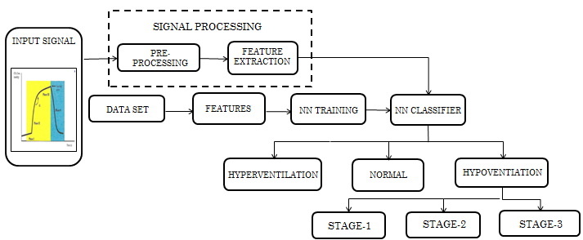

**3.2 BLOCK DIAGRAM DESCRIPTION**

**SIGNAL ACQUISITION:**

The database of 18 entries is acquired from CapnoBase.org. which contains annotated capnogram signals which gives the exhaled carbon-dioxide (CO2) concentration against time. The database also includes a benchmark dataset.

**PRE-PROCESSING:**

Signal pre-processing and dimensionality reduction is carried out using Median Filter and Masking Window technique to eliminate unnecessary noise in the recorded capnogram signals.

**Median filter:**

The median filter is a nonlinear [digital filtering](https://en.wikipedia.org/wiki/Digital_filter) technique, often used to remove [noise](https://en.wikipedia.org/wiki/Signal_noise). Such noise reduction is a typical pre-processing step to improve the results of later processing.  Median filtering is very widely used in digital [image processing](https://en.wikipedia.org/wiki/Image_processing) because, under certain conditions, it preserves edges while removing noise. The main idea of the median filter is to run through the signal entry by entry, replacing each entry with the [median](https://en.wikipedia.org/wiki/Median) of neighboring entries. The pattern of neighbors is called the "window", which slides, entry by entry, over the entire signal. For 1D signals, the most obvious window is just the first few preceding and following entries, whereas for 2D (or higher-dimensional) signals such as images, more complex window patterns are possible (such as "box" or "cross" patterns). If the window has an odd number of entries, then the [median](https://en.wikipedia.org/wiki/Median) is simple to define. It is just the middle value after all the entries in the window are sorted numerically. For an even number of entries, there is more than one possible median. Median filtering is one kind of smoothing technique, as is [linear Gaussian filtering](https://en.wikipedia.org/wiki/Gaussian_blur). All smoothing techniques are effective at removing noise in smooth patches or smooth regions of a signal, but adversely affect edges. Often though, at the same time as reducing the noise in a signal, it is important to preserve the edges. Median filter is effective for removing [speckle noise](https://en.wikipedia.org/wiki/Speckle_noise) and [salt and pepper noise](https://en.wikipedia.org/wiki/Salt_and_pepper_noise) (impulsive noise).

Median filter is implemented in MATLAB using the formula:

**Input = medfilt2 ( inp ' , [m n] )**

Where, [m n] is the size of the Masking Window. In our project, the length of the time capnograms are around 36000 ms and therefore, to filter the noise a [1 360] window is used to apply the median filter.

**FEATURE EXTRACTION**

Feature extraction transforms raw signals into more informative signatures or fingerprints of a system. Feature extraction a type of dimensionality reduction that efficiently represents interesting parts of an image or signal as a compact feature vector. This approach is useful when signal or image sizes are large and a reduced feature representation is required to quickly complete tasks such as signal matching and retrieval. Feature detection, feature extraction, and matching are often combined to solve common computer vision problems such as [object detection](http://in.mathworks.com/products/computer-vision/features.html) and [recognition](http://in.mathworks.com/discovery/object-recognition.html), content-based image retrieval, face detection and [recognition](http://in.mathworks.com/discovery/face-recognition.html), and texture classification. Common feature extraction techniques include Histogram of Oriented Gradients (HOG), Speeded Up Robust Features (SURF), Local Binary Patterns (LBP), Haar wavelets, and color histograms.

The main feature extracted is ETCO2 (end-tidal CO2). The other statistical parameters extracted are maximum peak, minimum and the average of the signal. The formulas used to extract the parameters are:

Mean value : ( ∑ X ) / N

Etco2 (peak value) : max ( max ( inp ) )

Minimum value : min ( min ( inp ) )

**NEURAL NETWORK:**

A Neural Network (NN) is an information processing paradigm that is inspired by the way biological nervous systems, such as the brain, process information. The key element of this paradigm is the novel structure of the information processing system. It is composed of a large number of highly interconnected processing elements (neurons) working in unison to solve specific problems. An NN is configured for a specific application, such as pattern recognition or data classification, through a learning process. Learning in biological systems involves adjustments to the synaptic connections that exist between the neurons.

Neural networks, with their remarkable ability to derive meaning from complicated or imprecise data, can be used to extract patterns and detect trends that are too complex to be noticed by either humans or other computer techniques. A trained neural network can be thought of as an "expert" in the category of information it has been given to analyze. This expert can then be used to provide projections given new situations of interest and answer "what if" questions. Other advantages include,

* Adaptive learning: An ability to learn how to do tasks based on the data given for training or initial experience.
* Self-Organization: An NN can create its own organization or representation of the information it receives during learning time.
* Real Time Operation: NN computations may be carried out in parallel, and special hardware devices are being designed and manufactured which take advantage of this capability.
* Fault Tolerance via Redundant Information Coding: Partial destruction of a network leads to the corresponding degradation of performance. However, some network capabilities may be retained even with major network damage.

Neural networks take a different approach to problem solving than that of conventional computers. Conventional computers use an algorithmic approach i.e. the computer follows a set of instructions in order to solve a problem. Unless the specific steps that the computer needs to follow are known the computer cannot solve the problem. That restricts the problem solving capability of conventional computers to problems that we already understand and know how to solve. But computers would be so much more useful if they could do things that we don't exactly know how to do.

Neural networks process information in a similar way the human brain does. The network is composed of a large number of highly interconnected processing elements (neurons) working in parallel to solve a specific problem. Neural networks learn by example. They cannot be programmed to perform a specific task. The examples must be selected carefully otherwise useful time is wasted or even worse the network might be functioning incorrectly.

On the other hand, conventional computers use a cognitive approach to problem solving; the way the problem is to solved must be known and stated in small unambiguous instructions. These instructions are then converted to a high level language program and then into machine code that the computer can understand. These machines are totally predictable; if anything goes wrong is due to a software or hardware fault.

Neural networks and conventional algorithmic computers are not in competition but complement each other. There are tasks are more suited to an algorithmic approach like arithmetic operations and tasks that are more suited to neural networks. A large number of tasks require systems that use a combination of the two approaches in order to perform at maximum efficiency.

This ability of a neural network to learn, to make adjustments to its structure over time, is what makes it so useful in the field of artificial intelligence. Here are some standard uses of neural networks in software today.

Pattern Recognition — This is the most common application. Examples are facial recognition, optical character recognition, etc.

Time Series Prediction — Neural networks can be used to make predictions.

Signal Processing — Cochlear implants and hearing aids need to filter out unnecessary noise and amplify the important sounds. Neural networks can be trained to process an audio signal and filter it appropriately.

Control — Neural networks are often used to manage steering decisions of physical vehicles.

Soft Sensors — A soft sensor refers to the process of analyzing a collection of many measurements. Neural networks can be employed to process the input data from many individual sensors and evaluate them as a whole.

Anomaly Detection — Because neural networks are so good at recognizing patterns, they can also be trained to generate an output when something occurs that doesn’t fit the pattern.

**3.3 PROBABILISTIC NEURAL NETWORKS (PNN):**

A probabilistic neural network (PNN) is a [feed forward neural network](https://en.wikipedia.org/wiki/Feedforward_neural_network), which is derived from the [Bayesian network](https://en.wikipedia.org/wiki/Bayesian_network) and a statistical algorithm called [Kernel Fisher discriminant analysis](https://en.wikipedia.org/wiki/Kernel_Fisher_discriminant_analysis). A probabilistic neural network (PNN) is predominantly a classifier which maps any input pattern to a number of classifications. It can be forced into a more general function approximator. In a PNN, the operations are organized into a multilayered feedforward network with four layers: Input layer, Hidden layer, Pattern layer/Summation layer, Output layer.

Probabilistic (PNN) and General Regression Neural Networks (GRNN) have similar architectures, but there is a fundamental difference: Probabilistic networks perform classification where the target variable is categorical, whereas general regression neural networks perform regression where the target variable is continuous. If a PNN/GRNN network is selected, DTREG will automatically select the correct type of network based on the type of target variable.

**General Architecture of a PNN:**

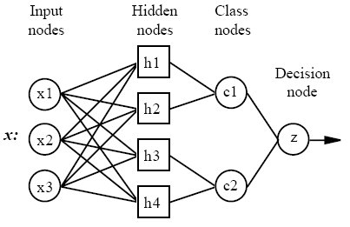

All PNN networks have four layers:

1. Input layer- There is one neuron in the input layer for each predictor variable. In the case of categorical variables, N-1 neurons are used where N is the number of categories. The input neurons (or processing before the input layer) standardize the range of the values by subtracting the median and dividing by the interquartile range. The input neurons then feed the values to each of the neurons in the hidden layer.
2. Hidden layer- This layer has one neuron for each case in the training data set. The neuron stores the values of the predictor variables for the case along with the target value. When presented with the x vector of input values from the input layer, a hidden neuron computes the Euclidean distance of the test case from the neuron’s center point and then applies the RBF (Radial Basis Function) kernel function using the sigma value(s). The resulting value is passed to the neurons in the pattern layer.
3. Pattern layer / Summation layer- The next layer in the network is different for PNN networks and for GRNN networks. For PNN networks there is one pattern neuron for each category of the target variable. The actual target category of each training case is stored with each hidden neuron; the weighted value coming out of a hidden neuron is fed only to the pattern neuron that corresponds to the hidden neuron’s category. The pattern neurons add the values for the class they represent (hence, it is a weighted vote for that category).
4. Decision layer- The decision layer is different for PNN and GRNN networks. For PNN networks, the decision layer compares the weighted votes for each target category accumulated in the pattern layer and uses the largest vote to predict the target category.

The following diagram is actual diagram or propose network used in our project.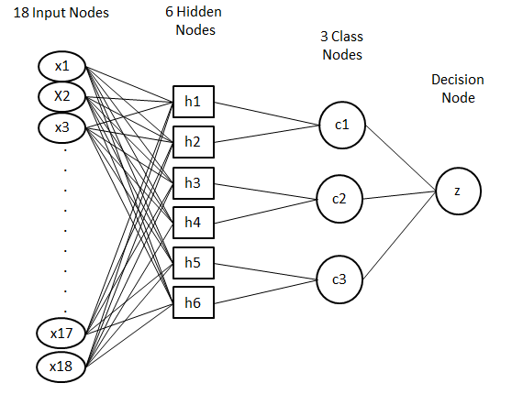

**1) Input Layer:**

The input vector denoted as p is presented as the black vertical bar. Its dimension is R×1. In our project, R = 3.

**2) Radial Basis Layer:**

In Radial Basis Layer, the vector distances between input vector p and the weight vector made of each row of weight matrix W are calculated. Here, the vector distance is defined as the dot product between two vectors. Assume the dimension of W is Q×R. The dot product between p and the i-th row of W produces the i-th element of the distance vector ||W-p||, whose dimension is Q×1. The minus symbol, “-”, indicates that it is the distance between vectors. Then, the bias vector b is combined with ||W- p|| by an element-by-element multiplication. The result is denoted as n = ||W- p|| . p. The transfer function in PNN has built into a distance criterion with respect to a center. In this project, it is defined as

radbas(n) = 2 n ------------- (1).

Each element of n is substituted into equation (1) and produces corresponding element of a, the output vector of Radial Basis Layer. The i-th element of a can be represented as

ai = radbas(||Wi - p|| . bi) ------------ (2)

where, Wi is the vector made of the i-th row of W and bi is the i-th element of bias vector b.

**3) Competitive Layer:**

There is no bias in Competitive Layer. In Competitive Layer, the vector a is firstly multiplied with layer weight matrix M, producing an output vector d. The competitive function denoted as C produces a 1 corresponding to the largest element of d, and 0’s elsewhere. The output vector of competitive function is denoted as c. The index of 1 in c is the number of tumor that the system can classify. The dimension of output vector K is 3 in this paper.

**CHAPTER 4**

**SOFTWARE DESCRIPTION**

**4.1 MATLAB**

MATLAB is a high-performance language for technical computing. It integrates computation, visualization, and programming in an easy-to-use environment where problems and solutions are expressed in familiar mathematical notation. Typical uses include:

* Math and computation
* Algorithm development
* Modeling, simulation, and prototyping
* Data analysis, exploration and visualization
* Scientific and engineering graphics
* Application development, including graphical user interface building

MATLAB is an interactive system whose basic data element is an array that does not require dimensioning. This provides solutions to many technical computing problems, especially those with matrix and vector formulations.

The name MATLAB stands for matrix laboratory. MATLAB was originally written to provide easy access to matrix software developed by the LINPACK and EISPACK projects. Today, MATLAB uses software developed by the LAPACK and ARPACK projects, which together represent the state-of-the-art in software for matrix computation.

MATLAB has evolved over a period of years with input from many users. In university environments, it is the standard instructional tool for introductory and advanced courses in mathematics, engineering, and science. In industry, MATLAB is the tool of choice for high-productivity research, development, and analysis.

MATLAB facilitates a family of application-specific solutions called toolboxes. These toolboxes are useful to learn and apply specialized technology. Toolboxes are comprehensive collections of MATLAB functions (M-files) that extend the MATLAB environment to solve particular classes of problems. Toolboxes are widely used in areas such as signal processing, control systems, neural networks, fuzzy logic, wavelets, simulation and many others.

**The MATLAB System:**

The MATLAB system consists of five main parts:

1. **Development environment:** This consists of a set of tools that facilitate the use of MATLAB functions and files. Many of these tools are graphical user interfaces. They include the MATLAB desktop and Command Window, a command history, and browsers for viewing help, the workspace, files and the search path.
2. **The MATLAB Mathematical Function Library:** This is a vast collection of computational algorithms ranging from elementary functions like sum, sine, cosine, tangent to more sophisticated functions like matrix inverse, matrix eigenvalues, Bessel functions, and fast Fourier transforms.
3. **The MATLAB Language:** This is a high-level matrix/array language which uses control flow statements, functions, data structures, input/output, and object-oriented programming features. It allows both "programming in the small" to rapidly create quick and dirty throw-away programs, and "programming in the large" to create complete large and complex application programs.
4. **Handle Graphics:** This is the MATLAB graphics system. It includes high-level commands for two-dimensional and three-dimensional data visualization, image processing, animation and presentation graphics. It also includes low-level commands that help in customizing the appearance of graphics as well as in building complete graphical user interfaces on MATLAB applications.
5. **The MATLAB Application Program Interface (API):** This is a library that provides facilities to write C and FORTRAN programs that interact with MATLAB. It includes facilities for calling routines from MATLAB (dynamic linking), calling MATLAB as a computational engine, and for reading and writing MAT-files.

**4.2 ALGORITHM**

**ALGORITHM FLOW:**

**PHASE 1:**

STEP 1: Open an M-File in MATLAB software.

STEP 2: Create an interface called ‘SimpleGUI’ .

STEP 3: Populate a structure called gui_State having 6 fields namely gui_Name, gui_Singleton, gui_OpeningFcn, gui_OutputFcn, gui_LayoutFcn and gui_Callback.

STEP 4: gui_Name is filled with mfilename. This is the current M-file so here ‘SimpleGUI’.

STEP 5: gui_Singleton is an option (0 or 1) that allows only one or several instance of your Gui to be started at the same time.

STEP 6: gui_OpeningFcn is filled with a function handle. It points at SimpleGUI_OpeningFcn.

STEP 7: gui_OutputFcn is filled similarly with another function, this function only send out handles.output in varargout. This varargout is transmitted via gui_mainfcn to the big varargout of SimpleGui.

STEP 8: gui_LayoutFcn is used when you actually don’t have an associated FIG file that stores all the objects on your interface. It would actually create the objects directly from the M-file. In this case, we have a FIG file so it is empty.

STEP 9: gui_Callback is empty at first and then it is filled in case varargin{1} which is a character. This is used to call some of your callback from outside.

**PHASE 2:**

STEP 1: Create a function called 'inp_signal'.

STEP 2: When the button 'Input Signal' on the GUI is clicked, it plots the graph named 'Input signal' with 'Time' on the X-axis and 'Concentration of Co2 (kPa)' on the Y-axis.

**PHASE 3:**

STEP 1: Create a function 'pre_process' for pre-processing of the input signal using the median filter.

STEP 2: If size ‘r’ of the input signal is equal to 36001, the window size is given as [1 360].

STEP 3: Else the window size is given as [1 36].

**PHASE 4:**

STEP 1: Create a function called 'Features'.

STEP 2: There are three features namely ETCO2 (PEAK), AVERAGE STEM AND MAXIMUM POINT are calculated.

STEP 3: These features are calculated using the formula:

* + - * MEAN VALUE : (∑X)/N
      * ETCO2(PEAK VALUE) : max(max(inp))
      * MINIMUM VALUE : min(min(inp))

STEP 4: Create a function called 'Database' having 18 entries.

STEP 5: Obtain the features namely mean, max, min for all the 18 signals.

**PHASE 5:**

STEP 1: Create a function 'nn_train' for probabilistic neural network training.

STEP 2: The 18 signals are given as input signals.

STEP 3: The 3 features extracted from each of the 18 signals are given as inputs.

STEP 4: The inputs are fed to the 6 hidden layers.

STEP 5: There are 3 output stages and one decision node.

STEP6: The output stages are HYPERVENTILATION, NORMAL VENTILATION and HYPOVENTILATION.

**PHASE 6:**

STEP 1: Create a function called 'Classifier'.

STEP 2: If ETCO2 falls below 4.0 kPa, then the condition is HYPERVENTILATION.

STEP 3: Else if ETCO2 is greater than 5.72, then the condition is HYPOVENTILATION which is divided into 3 stages.

STAGE 1: ETCO2 is between 5.72 and 6.2

STAGE 2: ETCO2 is between 6.2 and 7.1

STAGE 3: ETCO2 is between 7.1 and 8.0

STEP 4: Else if ETCO2 is between 4.0 to 5.72, there are two condition to check:

1. If ETCO2 is between 4.0 and 5.68, then it is NORMAL VENTILATION.
2. Else if it is between 5.68 and 5.72, then it is a special case called BRONCHOSPASM.

**4.3 PROCESS EXPLANATION:**

A database of 18 capnogram signals from Capnobase.org is utilized for our analysis. First, the signal is pre-processed using median filter and windowing technique. This is done to remove unwanted noise in the signal. A window size of [1 360] is chosen because the resolution increases as the size of the window decreases. To each window, the median filter is applied. It involves computing the median value from a row matrix arranged in ascending order and replacing the inaccurate elements of the matrix with the median value. Then the pre-processed signal undergoes feature extraction. The main feature considered is the maximum peak of the signal which is the End Tidal CO2 volume. The other features considered are the minimum and the average of the signal. The ETCO2 range for a normal healthy person is between 4 kPa to 5.7 kPa. These features are extracted by using formulae to determine for mean, maximum and minimum of the signal in MATLAB. These formulae are applied two-dimensionally across row and column for better accuracy. The capnogram signals are then trained using Probablistic Neural network (PNN) to classify them into normal ventilation, hypoventilation (mild) or hyperventilation (severe). Hyperventilation is further classified into 3 stages. Features from 18 input signals from the dataset are given as input nodes to the input layer. 6 hidden layers are used to classify the asthma severity into the 3 classes. These classes are given as 3 output nodes in the output layer. This computer aided patient assistive tool helps the physician in treating the patient according to the severity of asthma.

**CHAPTER 5**

**RESULTS AND DISCUSSION**

**5.1 RESULTS OBTAINED:**

|  |  |  |  |  |  |  |  |  |  |
| --- | --- | --- | --- | --- | --- | --- | --- | --- | --- |
|  | **1** | **2** | **3** | **4** | **5** | **6** | **7** | **8** | **9** |
| **AVERAGE STEM** | 3.429333 | 2.274557 | 3.142933 | 2.195185 | 2.374207 | 4.309458 | 2.092593 | 1.799096 | 2.980618 |
| **ETCO2 (PEAK)** | 5.800981 | 3.847589 | 5.525154 | 3.724032 | 3.02175 | 7.3108 | 3.539782 | 5.06929 | 5.71 |
| **MINIMUM POINT** | -0.06703 | -0.04446 | -0.05566 | 0.144768 | 0.09945 | 0.2842 | -0.0409 | 0.009999 | 0.36 |

|  |  |  |  |  |  |  |  |  |  |
| --- | --- | --- | --- | --- | --- | --- | --- | --- | --- |
|  | **10** | **11** | **12** | **13** | **14** | **15** | **16** | **17** | **18** |
| **AVERAGE STEM** | 2.286651 | 6.207078 | 3.499319 | 1.799348 | 2.921006 | 2.985786 | 2.793185 | 4.309458 | 6.207078 |
| **ETCO2 (PEAK)** | 3.8792 | 7.9 | 5.919368 | 5.07 | 5.5958 | 5.248896 | 3.555 | 7.3108 | 7.9 |
| **MINIMUM POINT** | 0.1508 | 0.26 | -0.0684 | 0.01 | 0.3528 | -0.05287 | 0.117 | 0.2842 | 0.26 |

* 1. **GRAPHICAL USER INTERFACE:**

The graphical user interface (GUI) developed in our project is as shown in the figure.

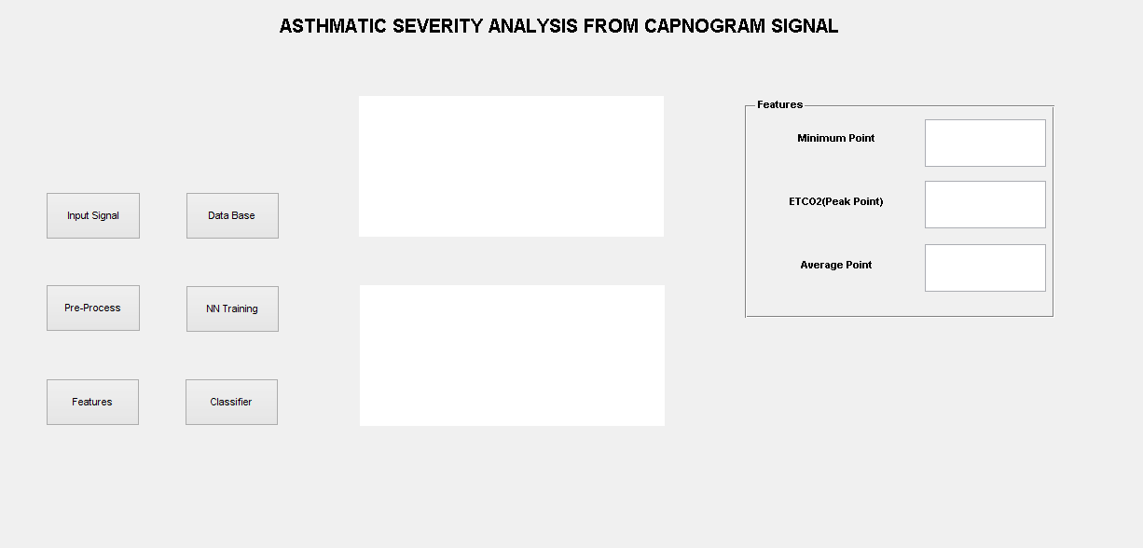

Various buttons are implemented to control the flow of the entire process. An Input Signal button is used to choose a particular capnogram signal from the database. The pre-process button executes the pre-process function to eliminate noise in the chosen signal. The features of the capnogram signal are displayed. NN training is applied to the signal on the click of NN Training button. The Classifier option is used to display the severity of asthma according to the analysis.

The GUI of normal capnogram signal is as shown in the figure.

**NORMAL VENTILATION:**

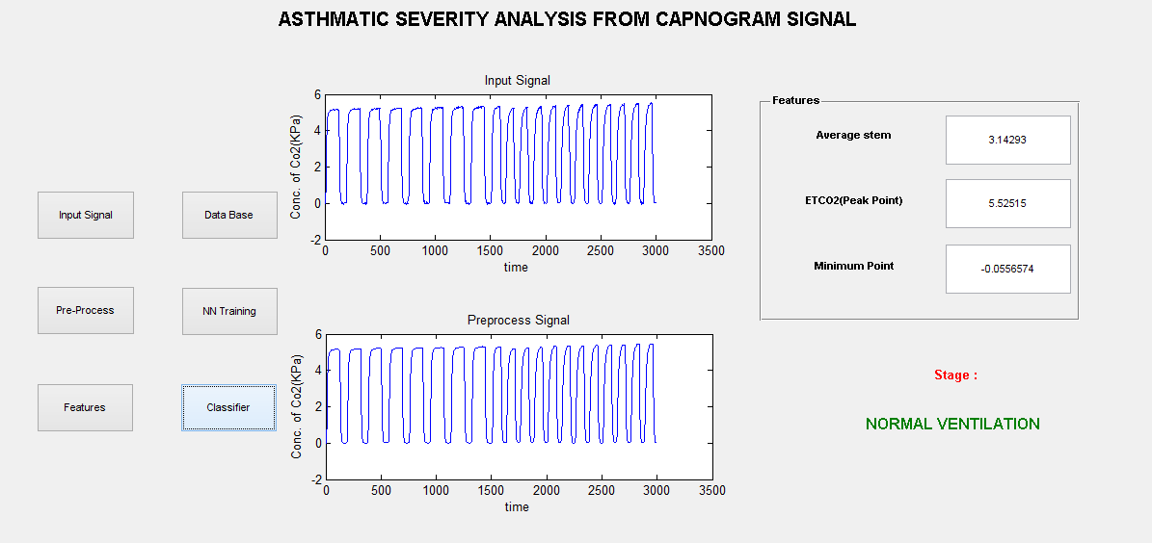

The following is a figure displaying the GUI corresponding to the Hyperventilation signal.

**HYPERVENTILATION:**

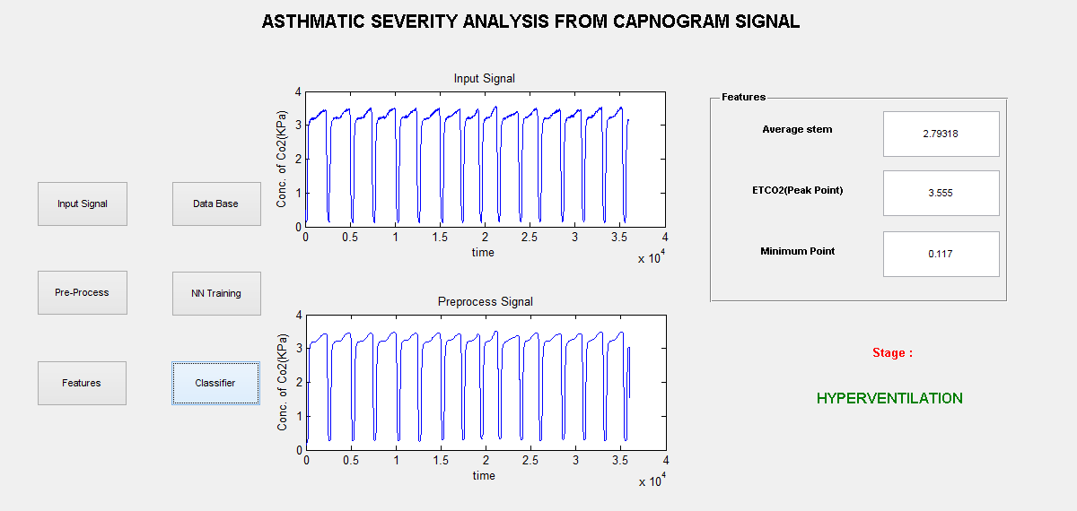

The following is a figure displaying the GUI corresponding to the Stage 3 of the Hypoventilation signal.

**HYPOVENTILATION:**

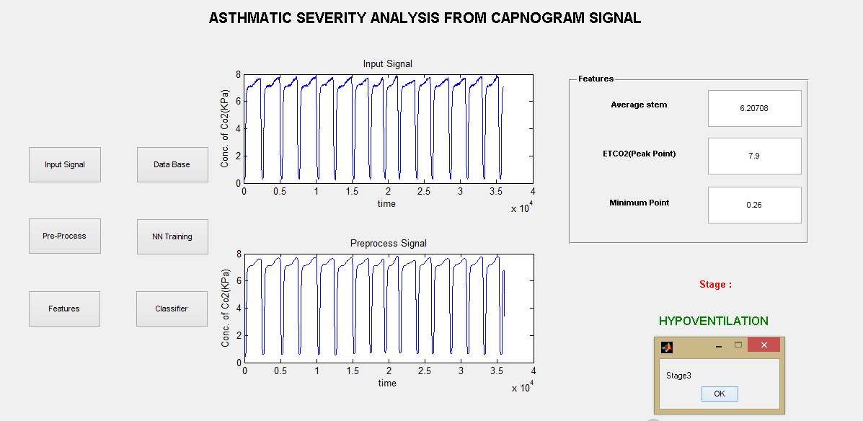

**NORMAL VENTILATION CAPNOGRAM:**

The following figure represents the input signal corresponding to the Normal ventilation classification.

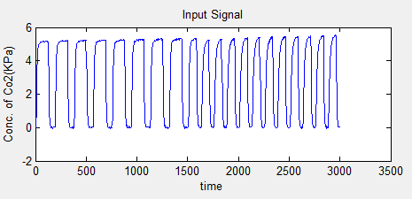

After pre-processing, the signal is devoid of noise and is shown in the following figure.

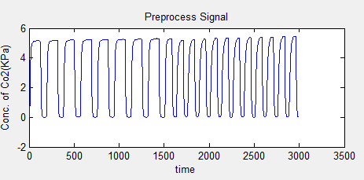

The pre-processed signal then undergoes feature extraction.

FEATURES OBTAINED:

|  |  |
| --- | --- |
| ETCO2 (MAXIMUM PEAK) | 5.525 |
| MINIMUM VALUE | 0.0556 |
| AVERAGE STEM | 3.14 |

**HYPERVENTILATION CAPNOGRAM:**

The following figure represents the input signal corresponding to the Hyperventilation classification.

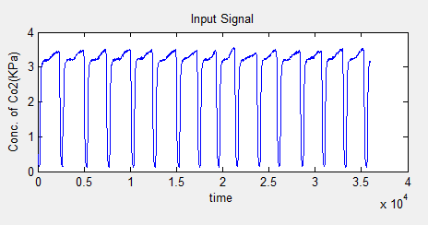

After pre-processing, the signal is devoid of noise and is shown in the following figure.

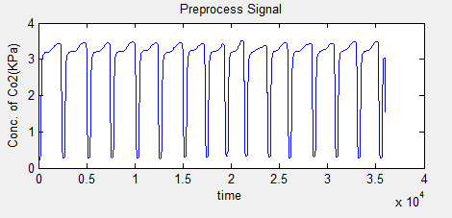

The pre-processed signal then undergoes feature extraction.

FEATURES OBTAINED:

|  |  |
| --- | --- |
| ETCO2 (MAXIMUM PEAK) | 3.555 |
| MINIMUM VALUE | 0.117 |
| AVERAGE STEM | 2.79218 |

**HYPOVENTILATION CAPNOGRAM:**

The following figure represents the input signal corresponding to the Hypoventilation classification.

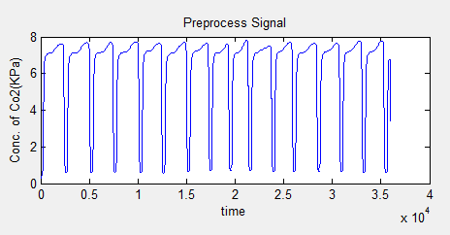

After pre-processing, the signal is devoid of noise and is shown in the following figure.

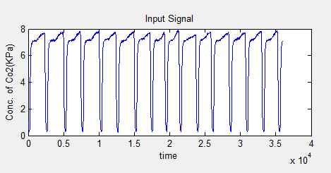

The pre-processed signal then undergoes feature extraction.

FEATURES OBTAINED:

|  |  |
| --- | --- |
| ETCO2 (MAXIMUM PEAK) | 7.9 |
| MINIMUM VALUE | 0.26 |
| AVERAGE STEM | 6.207 |

**BRONCHOSPASM:**

The following figure represents the input signal corresponding to the Bronchospasm condition.

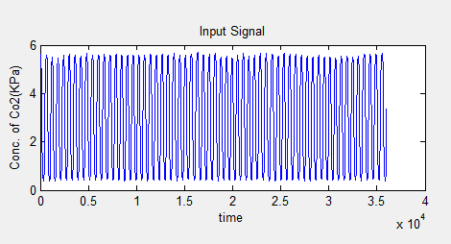

After pre-processing, the signal is devoid of noise and is shown in the following figure.

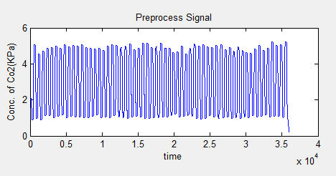

The pre-processed signal then undergoes feature extraction.

FEATURES OBTAINED:

|  |  |
| --- | --- |
| ETCO2 (MAXIMUM PEAK) | 5.71 |
| MINIMUM VALUE | 0.36 |
| AVERAGE STEM | 2.98062 |

­­

**5.3** **ADVANTAGES OF THE PROPOSED SYSTEM**

**5.4** **FUTURE WORK**

**REFERENCES:**